

Introduction

21 APRIL 2020

GAME JOLT API

DOCUMENTATION

DR.XAMÃ

DOCUMENTATION VALIDITY

This content was written and posted in April 2020. Current system version 2.5.0.

OBJECTIVE

The plugin makes the integration with the Game Jolt, allowing the complete use of the tool, from sending trophies to players to manipulating table scores. The system has a cloud storage mechanism, enabling players to have your games always at the last point on every device.

ABOUT THE AUTHOR

Luiz Guilherme dos Santos, 21 years old, is responsible for the public name "Dr.Xamã", responsible for the creation of all the material presented in the following internet domains, <www.drxama.com> and <www.drxama.com.br>, offered by GRUPO UOL.

DOCUMENT SUMMARY

This document aims to expose all the functionalities of the system.

Index

Page 4

Plugin installation.

Page 5

Use of the DX variable.

Page 6

Parameters.

Page 7

Notes.

Page 8

Plugin Commands 1.

Page 9

Plugin Commands 2.

Page 10

Script commands 1.

Page 11

Script commands 2.

Page 12

Script commands 3.

Page 13

Script commands 4.

Page 14

Game Jolt API 1.

Page 15

Game Jolt API 2.

Page 16

Video Links.

Page 17

Contact us.

Page 18

Publicity.

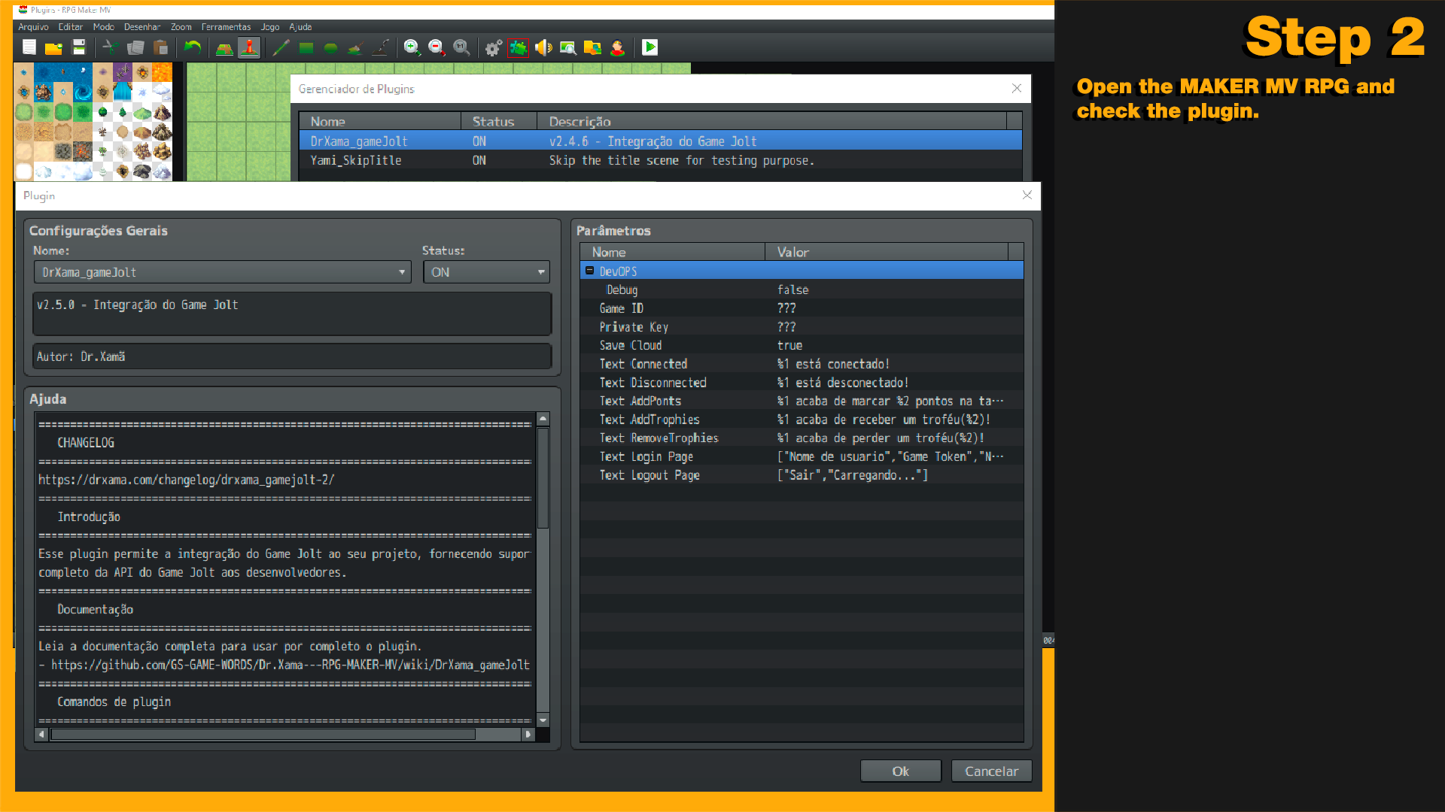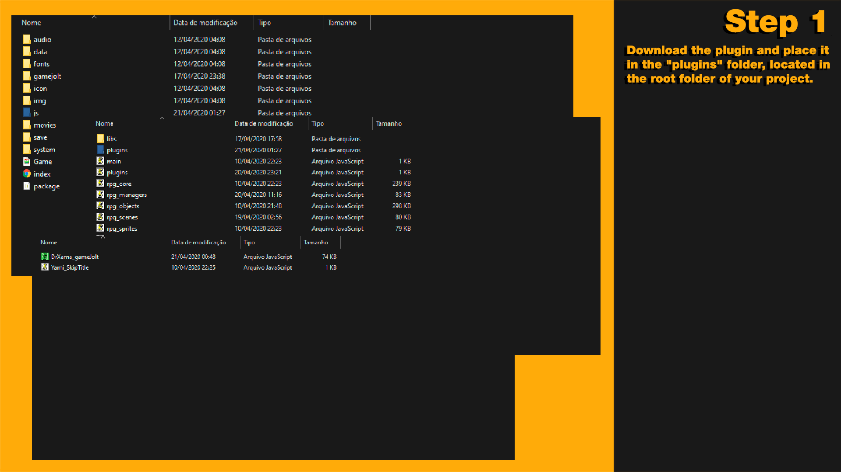Plugin InstallationUsing the DX variable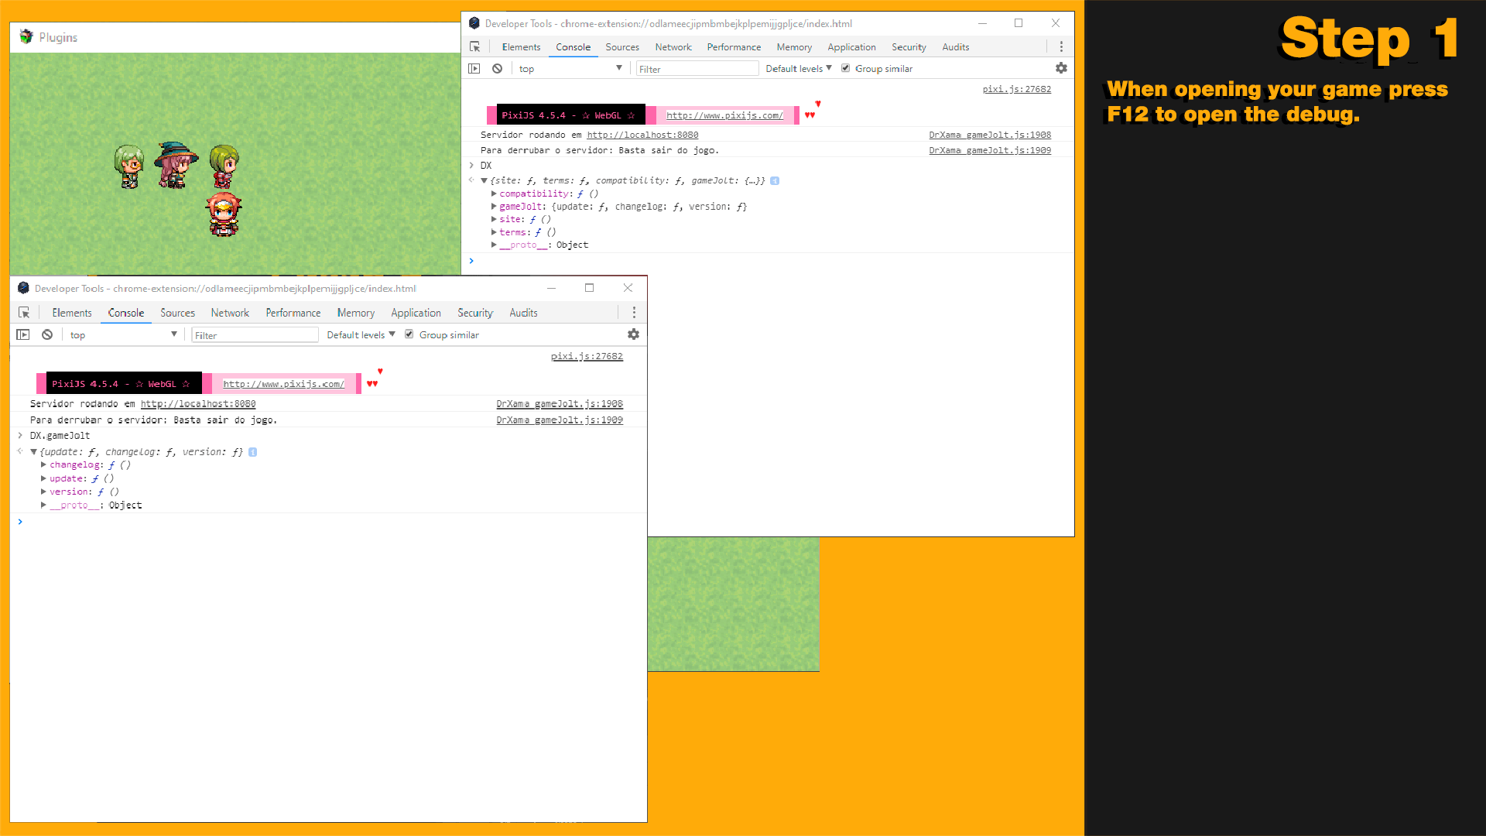Parameters

Overview

Follow the instructions below.

Commands

- DX.compatibility

Returns a message on debug saying if the plugin is compatible with your version of RPG MAKER MV.

- DX.site

Open Dr.Xamã official website.

- DX.terms

Open the terms of use page for Dr.Xamã plugins.

- DX.gameJolt.changelog

Opens the page containing information about all plugin updates.

- DX.gameJolt.update

Open the file page to download the latest version.

- DX.gameJolt.version

Returns a message on the debug containing the plugin version.

Official Domains, [www.drxama.com](http://www.drxama.com) and www.drxama.com.br.

Overview

See the images below.

DevOPS Debug

Activates/deactivates system debugging.

Game ID

ID of your game.

Private Key

Access key of your game API.

Save Cloud

Activate/deactivate the storage in the cloud.

Text Connected

Text presented when the user is connected.

%1 = Player Name

Text Disconnected

Text displayed when the user is disconnected.

%1 = Player Name

Text AddPonts

Text presented when the user marks a punctuation.

%1 = Player Name

%2 = Number of points

%3 = Table Name

Text AddTrophies

Text presented when the user receives a trophy.

%1 = Player Name

%2 = Trophy Name

Text RemoveTrophies

Text presented when the user loses a trophy.

%1 = Player Name

%2 = Trophy Name

Text Login Page

All texts displayed on the Login screen. The texts are in sequence.

Text Logout Page

All texts displayed on the Logout screen. The texts are in sequence.

Notes

* **When leaving the game all users sessions will be finalized.**
* **All commands related to users, should be done after users login. Wait until the login is complete to start a user related command.**
* **The system performs a Ping in the user's session every 3600(milliseconds), to inform that the user is active. By default the Game Jolt ends the user's session after 30 seconds of absence.**
* **Support for multiple users at the same time.**
* **Interface of login/logout elegant.**
* **Cloud storage system only works for the user logged in with the graphical interface, this prevents the file from being lost in multiuser synchronization.**
* **When the user logs into the system using the graphical interface, the system checks if there is a pending file for synchronization.**
* **For reasons of security and integrity of the player's files, it is recommended to the game developer, create an alert that notifies the player, that closing the game during the process of storing and uploading the files, may cause the loss of information and even corrupt the file data. In this possible situation, the system has both alerts during the upload of the files and the during storage, but the alert with a clear and descriptive text about the consequences of the actions described above, is responsibility by the game developer.**
* **The developer of the game must pay attention to create an alert based on RGPD, about the storage of player data such as name, password and personal information, and add a clause in the terms of contract of the game, informing the player that the same when making a connection to your account Game Jolt, the game has a storage in the cloud, if the player accepts, he runs the risk of losing his data in certain situations such as power outage, disconnection from the Internet, unexpected closure of the game, and other situations that may cause the transmission and receipt of data inconsistent or unfeasible.**

Plugin commands 1

GameJoltAddUser

Add a new Game Jolt user to your game.

**Username – Username of Game Jolt.**

**Game Token – Special Player Password, used to access the games.**

Example:

GameJoltAddUser DrXama 6da21e

GameJoltLoginUser

Start the user's session in the game.

**Username – Username of Game Jolt.**

**If you need to change the password of the player, because his registration was made with the wrong password, just register him again, the system recognizes that he is already registered and makes the change of password without registering him again, avoiding the duplication of the user in the system.**

Example:

GameJoltLoginUser DrXama

GameJoltLogoutUser

Ends the user's in-game session.

**Username – Username of Game Jolt.**

Example:

GameJoltLogoutUser DrXama

GameJoltScoresAddPoints

Adds the user's score to a Scoreboards table.

**Username – Username of Game Jolt.**

**TableID – Identifier number of the table.**

**Score – Number of points to be given to the player.**

**Sort - Maximum table or score value.**

Example:

GameJoltScoresAddPoints Username TableID Score Sort

GameJoltScoresAddGuestPoints

Add the guest score to a Scoreboards table.

**Guestname – Guest name.**

**TableID – Identifier number of the table.**

**Score – Number of points to be given to the player.**

**Sort - Maximum table or score value.**

Example:

GameJoltScoresAddGuestPoints Guestname TableID Score Sort

Plugin commands 2

GameJoltTrophiesAddUser

Add a trophy for the user.

**Username – Username of Game Jolt.**

**TrophyID – Trophy ID number.**

Example:

GameJoltTrophiesAddUser Username TrophyID

GameJoltTrophiesRemoveUser

Remove the user's trophy.

**Username – Username of Game Jolt.**

**TrophyID – Trophy ID number.**

Example:

GameJoltTrophiesRemoveUser Username TrophyID

GameJoltOpenWindowLogin

Call a graphical interface de login.

Example:

GameJoltOpenWindowLogin

GameJoltOpenWindowLogout

Call a graphical interface de logout.

Example:

GameJoltOpenWindowLogout

Script commands 1

$gameTemp.gameJoltAddUser

Add a new Game Jolt user to your game.

**Username(String) – Username of Game Jolt.**

**Game Token(String) - Special Player Password, used to access the games.**

Example:

$gameTemp.gameJoltAddUser('DrXama', '4a934x5p');

**The function will return true if the user registration is a success, and will return false if the registration is not successful.**

$gameTemp.gameJoltLoginUser

Start the user's session in the game.

**Username(String) – Username of Game Jolt.**

**Callback(Function) - Function to be returned with the answer.**

Example:

$gameTemp.gameJoltLoginUser('DrXama', success => { return console.log(success); });

**The function will return true if the user login is successful, and will return false if the login is not successful.**

$gameTemp.gameJoltLogoutUser

Ends the user's in-game session.

**Username(String) – Username of Game Jolt.**

**Callback(Function) - Function to be returned with the answer.**

Example:

$gameTemp.gameJoltLogoutUser('DrXama', success => { return console.log(success); });

**The function will return true if the user logout is successful, and will return false if the logout is not successful.**

$gameTemp.gamejoltScoresUserTable

Returns the score of the player in a certain **Scoreboards** table.

**Username(String) – Username of Game Jolt.**

**TableID(String) – Table Identifier Number.**

**Callback(Function) - Function to be returned with the answer.**

Example:

$gameTemp.gamejoltScoresUserTable('DrXama', '389349', score => { console.log(score); });

**The user must be logged in to perform a search for his score.**

Script commands 2

$gameTemp.gamejoltScoresTables

Returns all **Scoreboard** tables.

**Callback(Function) - Function to be returned with the answer.**

Example:

$gameTemp.gamejoltScoresTables(tables => { return console.log(tables); });

**The function returns a list (Array) with all the Scoreboards tables.**

$gameTemp.gamejoltScoresAddPoints

Adds the user's score to a **Scoreboards** table.

**Username(String) – Username of Game Jolt.**

**TableID(String) – Table Identifier Number.**

**Score(Number) – Quantities of points to be given to the player.**

**Sort(Number) - Maximum value of the score.**

**Callback(Function) - Function to be returned with the answer.**

Example:

$gameTemp.gamejoltScoresAddPoints('DrXama', '379357', 100, 45, success => { return console.log(success); });

**The function will return true if adding the user score is successful, and will return false if adding the user score is not successful. The sort value is used to set a limit for the score value, that is, if you set that score to 100 and sort to 45, the value to be recorded in the table will be 45.**

$gameTemp.gamejoltScoresAddGuestPoints

Add the guest score to a **Scoreboards** table.

**Guestname(String) – Guest name.**

**TableID(String) – Table Identifier Number.**

**Score(Number) – Quantities of points to be given to the player.**

**Sort(Number) - Maximum value of the score.**

**Callback(Function) - Function to be returned with the answer.**

Example:

$gameTemp.gamejoltScoresAddGuestPoints('convidado001', '379357', 100, 45, success => { return console.log(success); });

**The function will return true if adding the user score is successful, and will return false if adding the user score is not successful. The sort value is used to set a limit for the score value, that is, if you set that score to 100 and sort to 45, the value to be recorded in the table will be 45.**

Script commands 3

$gameTemp.gamejoltScoresGetRankTables

The function will return the **Scoreboards** score rating.

**TableID(String) – Table Identifier Number.**

**Sort(Number) – Score to be ranked.**

**Callback(Function) - Function to be returned with the answer.**

Example:

$gameTemp.gamejoltScoresGetRankTables('379357', 100, rank => { return console.log(rank); });

**The function will return the Scoreboards score rating.**

$gameTemp.gamejoltTrophiesUser

Returns all available trophies to the user.

**Username(String) – Username of Game Jolt.**

**TrophyId(String) – Trophy ID number.**

**Achieved(Boolean) - If the trophy was won by the user.**

**Callback(Function) - Function to be returned with the answer.**

Example:

$gameTemp.gamejoltTrophiesUser(‘Drxama’, ‘’, true, trophies => {return console.log(trophies); });

**The function will return a list (Array) with all the user's trophies. In achieved set true to return only the trophies won by the user. Set false to return only the trophies that the user did not get. Leave blank to retrieve all the trophies. In trophyId If you want to collect only one trophy, pass the trophy ID. If you do this, only this trophy will be returned in the answer. Setting a value for trophyId will ignore the achieved value.**

$gameTemp.gamejoltTrophiesAddUser

Add a trophy for the user.

**Username(String) – Username of Game Jolt.**

**TrophyId(String) – Trophy ID number.**

**Callback(Function) - Function to be returned with the answer.**

Example:

$gameTemp.gamejoltTrophiesAddUser('DrXama', '101982', success => { return console.log(success); });

**The function will return true if adding the user's trophy is successful, and will return false if adding the user's trophy is not successful.**

Script commands 4

$gameTemp.gamejoltTrophiesRemoveUser

Remove the user's trophy.

**Username(String) – Username of Game Jolt.**

**TrophyId(String) – Trophy ID number.**

**Callback(Function) - Function to be returned with the answer.**

Example:

$gameTemp.gamejoltTrophiesRemoveUser('DrXama', '101982', success => { return console.log(success); });

**The function will return true if removing the user's trophy is successful, and will return false if removing the user's trophy is unsuccessful.**

$gameTemp.gameJoltOpenWindowLogin

Call a graphical interface de login.

Example:

$gameTemp.gameJoltOpenWindowLogin();

$gameTemp.gameJoltOpenWindowLogout

Call a graphical interface de logout.

Example:

$gameTemp.gameJoltOpenWindowLogout();

Game Jolt API 1

Game Token

See below how you get it.

[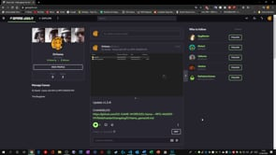](https://player.vimeo.com/video/410360188?app_id=122963)

Game ID and Private Key

See below how you get them.

[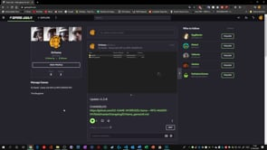](https://player.vimeo.com/video/410361795?app_id=122963)

Trophies

See below how you get them.

[](https://player.vimeo.com/video/410363534?app_id=122963)

Game Jolt API 2

Scoreboards

See below how you get them.

[](https://player.vimeo.com/video/410365417?app_id=122963)

Data Store

See below how you get it. Only the global values will be displayed.

[](https://player.vimeo.com/video/410367002?app_id=122963)

Video links

Game Token

<https://player.vimeo.com/video/410360188?app_id=122963>

Game ID e Private Key

<https://player.vimeo.com/video/410361795?app_id=122963>

Trophies

<https://player.vimeo.com/video/410363534?app_id=122963>

Scoreboards

<https://player.vimeo.com/video/410365417?app_id=122963>

Data Store

<https://player.vimeo.com/video/410367002?app_id=122963>

Contact us

Email 1

contato@drxama.com.br

Email 2

spgamesoficial@gmail.com

Publicity

Site

<https://drxama.com.br/> ou <https://drxama.com/>

Canal do Youtube

<https://www.youtube.com/channel/UCIL322VJEbtqIt53BLcn80w>

Github

<https://github.com/GS-GAME-WORDS/Dr.Xama---RPG-MAKER-MV>

Twitter

<https://twitter.com/dr_xama>

Discord

<https://discord.gg/bvS9fgB>